Madro-Tertiary Geoflora of the Pacific Northwest

Beginning about 65 million years ago, the climate of Western North American began to cool and became more arid, partly due to falling global temperatures and increasing global aridity, and partly in response to the initial uplift of the Sierra Nevada and Coast Range.

The rainshadow that resulted from these mountain barriers allowed the Madro-Tertiary Geoflora (from the Sierra Madre of Mexico) to expand its range and replace some of the Arcto-Tertiary plants in California, the Columbia Plateau, and Western Oregon and WA. Subsequent uplift of the Cascades increased the rainshadow effect in the interior PNW especially in the last ~20 million years. Rainshadow effects of the Olympic Mountains and Vancouver Island have created enough aridity for some of the drought-adapted Madro Tertiary Geoflora to extend well into Western Canada, including the northern sector of the Salish Sea (Strait of Georgia).

Most of the plants of Madro-Tertiary Geoflora in the PNW are drought adapted with some combination of small, deciduous, or waxy leaves. Some are found in fairly high precipitation zones (such as the coast) if the soils are coarse-grained with minimal moisture holding capacity. Summer hydrologic drought can be a factor in such zones.

Here are some prominent plants from this Geoflora to know:

Pacific Madrone Arbutus menzesii:
Photo:
https://i0.wp.com/realgardensgrownatives.com/wp-content/uploads/2017/11/Arbutus-menziesii-sRGB.jpg?w=640&ssl=1

Manzanita (genus Arctostaphylos) various species
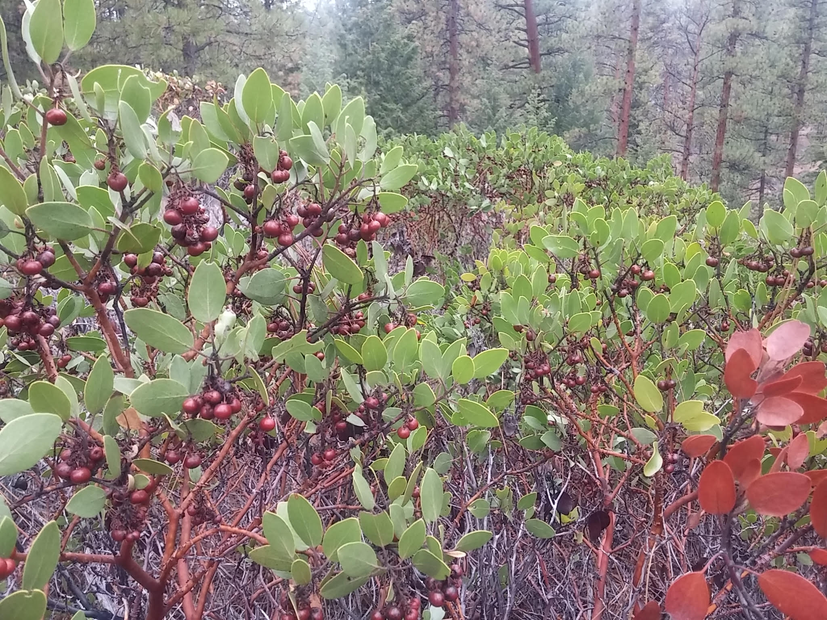

Western Juniper (Juniperus occidentalis)

Poison Oak (Toxicodendron diversilobum)
http://walking.about.com/od/medfirstaid/ig/Poison-Oak-Photos/Poison-Oak-Bush.htm

Oregon White Oak (Quercus garryana)

bunchgrasses

sages

students – if you’re interested in global temperature changes, this is a collection of temperature graphs over different time scales: http://math.ucr.edu/home/baez/temperature/temperature.html#65Myr

